EXPERIMENT- 33
Morphological Operations using Morphological Gradient Technique
Aim
To write a Python code to perform Morphological Gradient operation using OpenCV for extracting object boundaries from the image.
Input Image
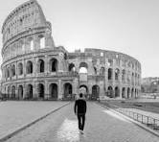
Code
from google.colab import files
import cv2
import numpy as np
from google.colab.patches import cv2_imshow
uploaded = files.upload()
image_path = list(uploaded.keys())[0]
image = cv2.imread(image_path, cv2.IMREAD_GRAYSCALE)
kernel = np.ones((5,5), np.uint8)
gradient = cv2.morphologyEx(image, cv2.MORPH_GRADIENT, kernel)
cv2_imshow(image)
cv2_imshow(gradient)
Output Image
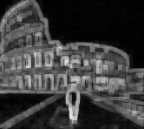
Result
Thus, the morphological gradient operation was successfully performed using OpenCV.

